|  |  |
| --- | --- |
| **Project 2 (Mandatory)** | **Linked List/Binary Search Tree** |
|  |  |

Binary Search Tree: Keyword Search

Background

Information retrieval systems allow users to enter keywords and retrieve articles that have those keywords associated with them. For example, once a student named Yi Li wrote a paper called, “Object Class Recognition using Images of Abstract Regions," and included the following keywords: `object recognition', `abstract regions', `mixture models', and `EM algorithm'. If someone does a search for all articles about the EM algorithm, this paper (and many others) will be retrieved.

Assignment

You are to implement a binary search tree and use it to store and retrieve articles. The tree will be sorted by keyword, and each node will contain an unordered linked list of Record objects which contain information about each article that corresponds to that keyword. This image shows the idea:

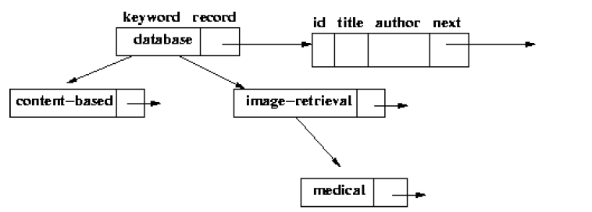

Available files and codes with the assignment:

* A Data file which contains records to be read into the data structure.
* Binary I/O: Chapter 17
* Linked List Code: Chapter 24
* Binary Search Tree: Chapter 25

Grading

1. Each node satisfies the binary search tree property that its key is greater than the key to its left child and less than the key of its right child

2. Insertions and deletions are done correctly and do not violate the binary search tree property.

3. Empty tree situations are handled properly.

4. All titles for a given key word are placed in the list at the node for that key word; they should be inserted at the BEGINNING of the list.